Orange Grove Adult Riders Club Inc.

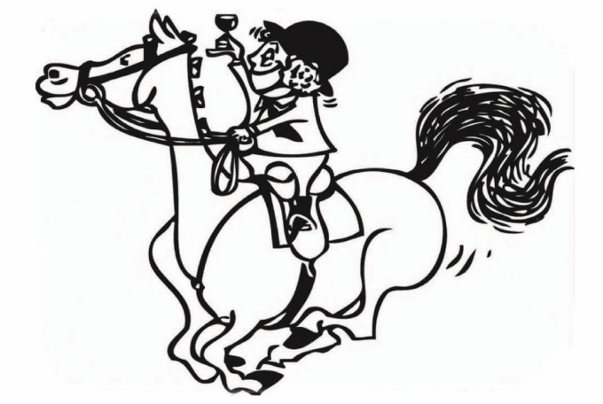

Handbook

Firstly, welcome to Orange Grove Adult Riders Club Inc.

This booklet covers the below items:

- Current Committee
- Membership
- Rally Information
- ARCA
- Uniforms
- Events
- Safety
- Arena Figures
- Arena etiquette

Current 2022 Committee

President: Nicky Munro

Secretary: Shelley Teakle

Treasurer: Alison Read

Rally Co-Ordinator: Deanna McDade

Uniforms:

Media:

Events Committee:

Committee Member’s: Alison McLay, Josh Cowley, andSarah Hodson

If you have any questions regarding rally groups you are in or anything else, please do not hesitate to make contact with any of our committee members, we are a friendly very approachable bunch.

If you have any suggestions, please feel free to mention them and we can raise them up at our next committee meeting. We are always open to new positive suggestions to improve our club for you.

If you are interested in joining the committee, please advise one of our committee members at a rally. There is always room for energetic and motivated members to help share the load.

Membership

Membership is open to members 18 years and over.

Our annual membership is from January to December.

We are affiliated with EA, so your membership includes Public Liability insurance while you are riding on the Karinya Equestrian Park at any time.

Annual Membership Fees

Membership $200.00
Includes Liability Insurance, Pavilion Hire, Council Fees & Rates
ARCA Levies
EA Affiliation

Membership fees are payable in full by the first Rally.

If you require 24/7 Personal Insurance, please visit the WA Equestrian website for the different levels of insurance available. This will Insure yourself anywhere at any time, so is well worth having for peace of mind.
http://www.wa.equestrian.org.au/

Rally Fees

All rally entries are via Nominate.

Registrations open the day after the previous rally and closes the Friday prior to the rally date.

$30.00 for the first Rally
$25.00 for the second = $55.00 for 2 Lessons.

All our instructors are certified Level 1 & 2 NCAS, and also Coach Educators.
If you are unable to make it to a rally, please let the Rally Co-Ordinator know in advance. We can credit fees to next rally with Vet Certificate or by Thursday prior to the rally.

Rally Setup

All members are expected to help setup and pack away equipment for the day’s lessons whether, it is flat work, poles, show jumping or x-country. Many hands make light work.

NB: please see Rally Co-ordinator for Poles/Show Jumping set up plan.

Rally Lunch

We have a lunch at every rally, which is a good chance to meet and mingle with fellow riders over lunch and a cool beverage. There will be a roster at the beginning of the year, so you will know what you are supposed to bring when it’s your turn.

Adult Riders Club Association

As an Adult Riders Club, we are also involved in 3 ARCA challenges throughout the year, for those that wish to compete. This is a competition run between all ARCA Affiliated Adult Rider Clubs in WA. They are a lot of fun, relaxed and very encouraging days. They are a good way to learn about what the various competitions involve and gain confidence.

Uniforms

You will be able to order uniforms at the join up day, they will be there for collection at the first rally.

Costs are:

Polo Shirt $50.00
Soft Shell Jackets $85.00
Soft Shell Vests $50.00
Ice Arms $10.00
White Saddle Cloth $70.00
Grey Saddle Cloth $70.00

All include our club logos and your name on clothing. Pictures are available on our website. All orders must be paid in full before they will be ordered.

All uniforms items are available throughout the year, so don’t feel like you need to purchase everything all at once.

General Rally uniform is a club shirt, and grey jodhpurs or White for competitions. Club uniforms are optional but preferred. Please present neat, tidy and on time for the Instructors.

Approved safety approved helmet must be worn.

Please note, when representing OGARC at ARCA challenges you are required to wear full club uniform of Club shirt, white or light-coloured jodhpurs, gloves, long boots or chaps with matching colour boots and tidy hair. If representing the club in turnout, you should all be dressed in the same full club uniform.

Events

Throughout the year we host several events, which help us to fund the club and cover our running costs for the year.

It is part of our terms and conditions of our Membership, to help out at least 3 of these events throughout the year. This includes, set up to pack up and everything in between. These competition days are our only form of income/fundraising to keep our club going, if you choose not to support these days it affects everyone.

You will be given the option for which events you would like to help at. Individual jobs will be allocated closer to the time, but you can express interest in what you would like to do. All information and training will be provided to carry out these jobs (i.e. gear checkers will have current EA regulations supplied).

If for some reason you are not able to make your rostered helper duty, or do not wish to do it, a $50 donation can be made to the club, for each event, so we can pay a helper to fill your allocated job. If this donation is not made, you will be expected to fill your roster.

The Orange Grove Adult Riding Club is a team and many hands make light work and strengthens relationships, so your support in any way is always appreciated.

Helper Duties on the day will be, but not limited to:

Dressage Penciller’s
Runners
Marshall’s
Gear Checker

Show Jumping Penciller’s
Marshall’s
Jump Poll Steward’s
Gear Checker

X-Country Jump Judge
Runners
Gear Checker

Hacking Penciller’s
Marshall’s

Overall Canteen
Scoring

Housekeeping

Front Gates
Please ensure the gates are closed after passing through them, for the safety of all horses on the grounds.

First Aid
Our first aid kit is kept in Room 1 at the undercover arena end of the pavilion.
If anything needs to be replenished, please let a committee member know.

Gear
Members are expected to inspect their gear regularly and make sure it is in safe working order and clean. Keep an eye out for any fraying stitching.

Yards
Please ensure you remove your left-over hay and manure from your yard. You can scatter the manure on an area without grass and hay to be taken home. Please leave the yard tidier that when you first got there.

Please ensure all rubbish is either taken home or put in bins on the grounds.

Damages
Please report any damages you find, to a committee member, so required repairs can be carried out.

Dogs
No dogs are allowed on the grounds at any time.

Lunging
Lunging is only to be carried out in designated areas. ie in the fenced area at the back of the grounds, not in any of the arenas.

Rally Lessons
Please read through the arena etiquette section, and abide by this when riding in a lesson. If you are having trouble with your horse at any time please remove yourself from the lesson, until you have your mount under control, so you don’t disrupt the whole lesson.

Arena Etiquette

If travelling in the opposite direction pass left shoulder to left shoulder.

If travelling in the same direction, let riders know if you are going to pass, or turn a circle.

If you are walking move to the centre of the arena so others can pass on the outside.

Leave at least two horse lengths between you and the horse in front of you, if need be, turn a circle to create some distance.

If you need to halt, please move to the middle of the arena.

Riders must be courteous to other riders and instructors.

What are Figures?
Figures are “prescribed paths a horse is ridden on in a riding arena, which provides markers that can help indicate the correctness in the size or shape of a figure”
Why - gives rider feedback about their own skills (a poor circle may indicate the rider sits crooked)

- gives rider feedback about their horse’s training and weaknesses (a poor circle may indicate the horse pops out a shoulder)
- figures are used in dressage tests, reining tests, jumping courses, and some equitation classes
- they encourage development of core strength – “By guiding the horse through geometric figures and changes of tempo or gait, the rider must make adjustments to their own posture in order to maintain an upright, balanced position.
