ORANGE GROVE ADULT RIDERS INC.

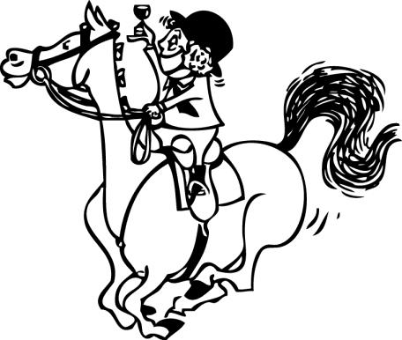

Join Up Day
28th January 2023 9AM - 12 PM

Please take the time to carefully read all the forms within this pack before signing

Welcome new and old members
Come and enjoy a fantastic year with us at
Karinya Equestrian Park
27 Grant Street, Orange Grove

Membership Enrolment Form for 2023

Website: www.orangegrovearc.com

Email completed forms to ogarcmembership@gmail.com

Name:
Address: Postcode:
Mobile: Date of Birth:
Email:
Mounts Name:
Mounts Age:
Mounts Height:
Membership fees for 2023 is $200 (must be paid in full by the first rally)

Payment may be made through Direct Debit, or Cash on Join Up Day

Account Name: Orange Grove Adult Riders Club Inc
BSB: 066128
Account number: 10496156
Reference: Surname and ‘membership’

Rally Fees (not included in membership fees)

$30.00 for first, $25 for second lesson. Lesson fees are payable in advance through Nominate. If you do not advise that you can’t make your lesson or lessons before the Thursday your fees are not refundable or transferable. Unless you have a vet or doctor certificate, as we have to pay the instructor for your position.

**Orange Grove Adult Riders Inc. does not provide Personal Insurance coverage for Adult Rider members. Personal Insurance is the responsibility of each Member.

Please Indicate if you are a member EWA member

JOINING AGREEMENT OF ORANGE GROVE ADULT RIDERS CLUB INC.

1. Enrolment signifies acceptance of the rules and constitution.

2. All riding members are required to assist at Orange Grove Adult Riders Inc. run events, which will consist of either: pencilling, marshalling, gear checking, scoring, setting up and pack up for the events, or any assistance with the actual organization on the day. In joining OGAR members undertake to do at least 3 helper duties at events a year.

3. By signing this form, you also give consent and authorisation for the members on the enrolment form to be photographed at the Orange Grove Adult Riders Inc. grounds and when representing the club at events held at other venues.

4. It is compulsory to assist with setting up and/or packing away at each rally that you attend. Failure to do so will result in not being eligible for any club trophies at the end of the year or a suspension of membership.

5. To abide by the Karinya Management rules. All manure must be removed from yards after use and spread over the adjoin grounds. Strictly no lunging in the sand arenas. Only members are allowed to ride at the grounds at any time. No Dogs on grounds.

By Signing hereunder, I confirm having read and understood and agree to the contents of this enrolment form.

Name Signature Date

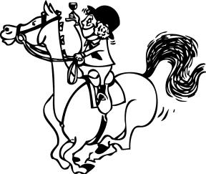
ORANGE GROVE ADULT RIDERS INC.

Section A: Medical and Consent Form Confidential

Name of Participant: Date of Birth: Address: Mobile No:

Contact: (In case of emergency)
Telephone: Mobile
Relationship to participant:

This form is to be completed by the rider that is attending activities of the Orange Grove Adult Riding Club Inc. The information contained herein may be required by a medical practitioner in the event of a rider requiring emergency treatment. The information given here is not intended to stop a rider participating in the activity. It is important for the wellbeing of the Rider that this form be completed fully and accurately.

Are you in a medical insurance fund? Yes/no; If so, which fund:
Does the above-named participant suffer from any of the problems listed below?
If ‘yes’ please circle and provide details.
(A) Heart Problems: Yes/No Details:

(B) Respiratory Problems:
(i) Asthma Yes/No; Do you carry and inhaler Yes/No?
(ii) Other Yes/No Details:

(C) Allergies
(i) Food Yes/No
(ii) Drugs Yes/No
(iii) Ointment Yes/No
(iv) Other Yes/No Details:

(D) Diabetes Yes/No Details:

(E) Blood Pressure Yes/No Details:

(F) Recent Operations Yes/No Details:

(G) Recent Illness Yes/No Details:

(H) Past Injuries Yes/No Details:

I consent the above-named participant to be allowed emergency medical/dental attention, if necessary, during the participation in any activity. Yes / No (Please circle)

I understand that no liability will be accepted by Orange Grove Adult Riders Inc. in the event of an injury or accident occurring.

I understand that Orange Grove Adult Riders Club Inc. reserves the right to refuse any person access to Orange Grove Adult Riders Club Inc. activities if it is reasonably believed that participation may be detrimental to the person’s health.

In the case of emergency, and I cannot be contacted, I give permission for the above-named participant to be transported by private car, ambulance or whatever other means is appropriate, and agree to cover the cost of such transport.

In the case of emergency and I cannot be contacted, I give permission for an Orange Grove Adult Riders Club Inc. Official to allow treatment of the participant as deemed necessary and agree to cover the cost of such transport.

I have disclosed all information, to the best of my knowledge, required by this form. The above-named participant is cleared by their registered Medical Practitioner to undertake all Orange Grove Adult Riders Club Inc. Activities. In the case that a medical restriction has been imposed on certain activities, I have listed these below:

I have read and fully understood the content of this Medical and Consent Form.

Signature Date

ORANGE GROVE ADULT RIDERS INC.

Section B: Self-assessment for year 2023

Name:
Email:
Horse’s name: Age:
How often do you ride each week: day’s
Are you currently competing? Yes/No
If you are not competing, and would like to, what discipline would you try:
What do you currently do with your Horse:
Hack Out: Yes/No
Dressage: Yes/No Level:
Show Jumping Yes/No Height:
Eventing: Yes/No Height:
Western: Yes/No
Other: Details:

Typical training sessions incorporates:
This year, what would you like to achieve with your horse:
Would you like to compete at the ARCA Challenges through the year?
Is there anything you would like to specifically learn more about this year (Horse Massage, Reining, Working Equitation)?

Why have you chosen to join Orange Grove Adult Riders?

Where did you hear about Orange Grove Adult Riders Club?
** If you have more than one horse, please write details on the back of this sheet **

Rally dates 2023:
February 25th (Familiarisation day) | July 9th
March 4th | August 6th
March 26th | September 17th
May 21st | October 8th
June 4th | November 12th

